# Introduction

## About G’Day

G’Day Telephone Directory provides;

* Immediate access to telephone numbers;
* Immediate access to business mobile numbers;
* Immediate access to fax numbers;
* Immediate access to email addresses;
* Immediate access to business address.

G’Day is not another database you must maintain;

* Stores your contacts in memory;
* Stores your staff telephone numbers in memory;
* Runs as a service on your computer.

G’Day is configurable;

* Your company’s name can be displayed in the banner;
* Your company’s logo can be displayed in the banner;
* Your company’s existing Directory Services database is used;
* Your company’s existing policies control what is displayed.

All of this information is available at your finger tips, Ctrl + Alt + P. The software is able to do this by running as a service on your computer and caches this information in memory for instant retrieval.

G’Day Telephone Directory Published by Wollundra Pty Ltd



Registered Offices: Unit 3 63 Pearson Street Holder ACT 2611

First released by Wollundra Pty Ltd Australia in 2010.  
The first retail version released by Wollundra Pty Ltd, February 2010.  
The first commercial installation 1 February 2010.

<http://wollundra.com>

## License Agreement

**G’Day Telephone Directory - Desktop, Professional and Corporate Editions, Version 1.07**

Copyright © 2009 - 2010 WOLLUNDRA Pty Ltd. All Rights Reserved

**IMPORTANT - READ CAREFULLY:** This End User License Agreement ("EULA") is a legal agreement between YOU as Licensee and WOLLUNDRA Pty Ltd A.C.N. 075 477 048 ("WOLLUNDRA") for the SOFTWARE PRODUCT identified above. By installing, copying, or otherwise using the SOFTWARE PRODUCT, YOU agree to be bound by the terms of this EULA. If YOU do not agree to the terms of this EULA, promptly return the unused SOFTWARE PRODUCT to the place of purchase for a full refund.

The copyright of the SOFTWARE PRODUCT and its documentation is owned by WOLLUNDRA. Subject to the terms of this EULA, YOU are granted a non-exclusive right for the duration of the EULA to use the SOFTWARE PRODUCT. YOU do not acquire ownership of copyright or other intellectual property rights in any part of the SOFTWARE PRODUCT by virtue of this EULA.

Your use of this software indicates your acceptance of this EULA and warranty.

**DEFINITIONS**

In this End User License Agreement, unless the contrary intention appears,

* "ACADEMIC EDITION" means an edition of the Software Product purchased for educational purposes at an academic discount price.
* "EULA" means this End User License Agreement
* "Licensee" means YOU, or the organization (if any) on whose behalf YOU are making the EULA.
* "Registered Edition of Telephone Directory" means the edition of the SOFTWARE PRODUCT which is available for purchase from the web site, following the thirty-day free evaluation period.
* "SOFTWARE PRODUCT" or "SOFTWARE" means Telephone Directory, UML Case Tool, Desktop, Professional and Corporate editions, which includes computer software and associated media and printed materials, and may include online or electronic documentation.
* "Support Services" means email-based support provided by WOLLUNDRA, including advice on usage of Telephone Directory, investigation of bugs, fixes, repairs of models, if and when appropriate, and general product support.
* "Trial edition of Telephone Directory" means the edition of the SOFTWARE PRODUCT which is available free of charge for evaluation purposes for a period of thirty (30) days.
* "EA LITE" means the LITE version of Telephone Directory that is distributed free of charge as a read-only viewer of EAP files.

**GRANT OF LICENSE**

In accordance with the terms of this EULA, YOU are granted the following rights:

* To install and use one copy of the SOFTWARE PRODUCT, or in its place, any prior version for the same operating system, on a single computer. As the primary user of the computer on which the SOFTWARE PRODUCT is installed, YOU may make a second copy for your exclusive use on either a home or portable computer.
* To store or install a copy of the SOFTWARE PRODUCT on a storage device, such as a network server, used only to install or run the SOFTWARE PRODUCT over an internal network. If YOU wish to increase the number of users entitled to concurrently access the SOFTWARE PRODUCT, YOU must notify WOLLUNDRA Pty Ltd and agree to pay an additional fee.
* To make copies of the SOFTWARE PRODUCT for backup and archival purposes only.

**EVALUATION LICENSE**

The Trial version of Telephone Directory is not free software. Subject to the terms of this agreement, YOU are hereby licensed to use this software for evaluation purposes without charge for a period of thirty (30) days. Upon expiration of the thirty (30) days, the Software Product must be removed from the computer. Unregistered use of Telephone Directory after the 30-day evaluation period is in violation of Australian, U.S. and international copyright laws.

WOLLUNDRA may extend the evaluation period on request and at their discretion. If YOU choose to use this software after the 30-day evaluation period, a license must be purchased. Upon payment of the license fee, YOU will be sent details on where to download the registered edition of Telephone Directory and will be provided with a suitable software 'key' by email.

**ADDITIONAL RIGHTS AND LIMITATIONS**

YOU hereby undertake not to sell, rent, lease, translate, adapt, vary, modify, decompile, disassemble, reverse engineer, create derivative works of, modify, sub-license, loan or distribute the SOFTWARE PRODUCT other than as expressly authorized by this EULA. YOU further undertake not to reproduce or distribute license key-codes except under the express and written permission of WOLLUNDRA.

If the Software Product purchased is an Academic Edition, YOU ACKNOWLEDGE THAT the license is limited to use in an educational context, either for self-education or use in a registered teaching institution. The Academic Edition may not be used to produce commercial software products or be used in a commercial environment, without the express written permission of WOLLUNDRA.

**ASSIGNMENT**

YOU may only assign all your rights and obligations under this EULA to another party if YOU supply to the transferee a copy of this EULA and all other documentation including proof of ownership. Your license is then terminated.

**TERMINATION**

Without prejudice to any other rights, WOLLUNDRA may terminate this EULA if YOU fail to comply with the terms and conditions. Upon termination YOU or YOUR representative shall destroy all copies of the SOFTWARE PRODUCT and all of its component parts or otherwise return or dispose of such material in the manner directed by WOLLUNDRA.

**WARRANTIES AND LIABILITY**

**WARRANTIES**

WOLLUNDRA warrants that;

* The SOFTWARE PRODUCT will perform substantially in accordance with the accompanying written materials for a period of ninety (90) days from the date of receipt, and any support services provided by WOLLUNDRA shall be substantially as described in applicable written materials provided to YOU by WOLLUNDRA, and WOLLUNDRA support engineers will make commercially reasonable efforts to solve any problems associated with the SOFTWARE PRODUCT.

**EXCLUSIONS**

To the maximum extent permitted by law, WOLLUNDRA excludes, for itself and for any supplier of software incorporated in the SOFTWARE PRODUCT, all liability for all claims, expenses, losses, damages and costs made against or incurred or suffered by YOU directly or indirectly (including without limitation lost costs, profits and data) arising out of:

* YOUR use or misuse of the SOFTWARE PRODUCT;
* YOUR inability to use or obtain access to the SOFTWARE PRODUCT;
* Negligence of WOLLUNDRA or its employees, contractors or agents, or of any supplier of software incorporated in the SOFTWARE PRODUCT, in connection with the performance of WOLLUNDRA's obligations under this EULA; or
* Termination of this EULA by either party for any reason.

**LIMITATION**

The SOFTWARE PRODUCT and any documentation are provided "AS IS" and all warranties, whether express, implied, statutory or otherwise, relating in any way to the subject matter of this EULA or to this EULA generally, including without limitation, warranties as to: quality; fitness; merchantability; correctness; accuracy; reliability; correspondence with any description or sample, meeting your or any other requirements; uninterrupted use; compliance with any relevant legislation; and being error or virus free are excluded. Where any legislation implies in this EULA any term, and that legislation avoids or prohibits provisions in a contract excluding or modifying such a term, such term shall be deemed to be included in this EULA. However, the liability of WOLLUNDRA for any breach of such term shall, if permitted by legislation, be limited, at WOLLUNDRA's option to any one or more of the following upon return of the SOFTWARE PRODUCT and a copy of the receipt:

If the breach relates to the SOFTWARE PRODUCT:

* The replacement of the SOFTWARE PRODUCT, or the supply of an equivalent SOFTWARE PRODUCT;
* The repair of such SOFTWARE PRODUCT, or the payment of the cost of replacing the SOFTWARE PRODUCT, or of acquiring an equivalent SOFTWARE PRODUCT; or
* The payment of the cost of having the SOFTWARE PRODUCT repaired.

If the breach relates to services in relation to the SOFTWARE PRODUCT:

* The supplying of the services again; or
* The payment of the cost of having the services supplied again.

**TRADEMARKS**

All names of products and companies used in this EULA, the SOFTWARE PRODUCT, or the enclosed documentation may be trademarks of their corresponding owners. Their use in this EULA is intended to be in compliance with the respective guidelines and licenses. Windows, Windows 98, Windows NT, Windows ME, Windows XP, Windows 2000, Windows 2003 Server and Windows Vista are trademarks of Microsoft.

**GOVERNING LAW**

This agreement shall be construed in accordance with the laws of the Commonwealth of Australia, in the states of Commonwealth of Australia.

# Admin Configuration

## Look & Feel

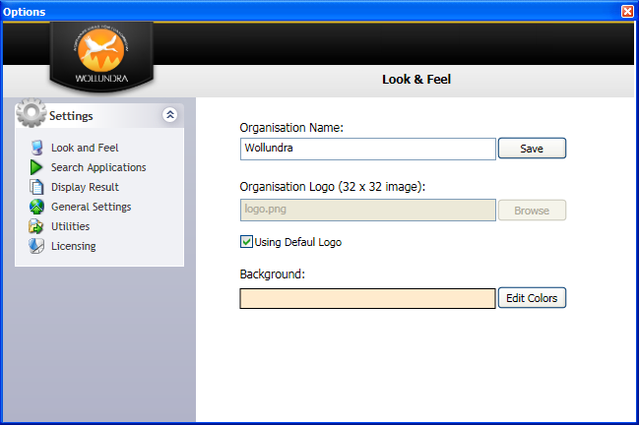

Organisation Name:

* This is displayed in the banner of the G’Day screen;
* This is configurable to show company name or your name;

Organisation Logo (32 x32 image):

* G’Day can be further customised to display your company logo;
* Image files (32 x 32 pixels) can be loaded;
* A default logo will be displayed if no logo is specified.

Using Default Logo

* If selected the services default logo will be displayed.

Background:

* The displayed background colour is configurable;
* Normally this will be set to reflect the corporate colours.

## Search applications

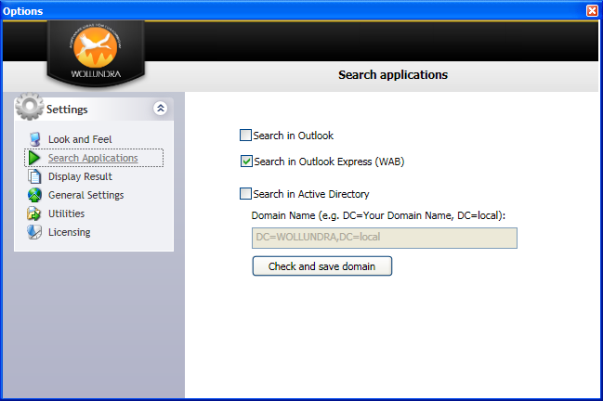

Search in Outlook

* This check box configures the service to cache your Microsoft Outlook contacts;
* If you use another mail client this option will be ignored.

Search in Outlook Express (WAB)

* This check box configures the service to cache your Microsoft Outlook Express contacts;
* If you use another mail client this option will b e ignored.

Search in Active Directory

* This check box configures the service to cache your Active Directory users;
* To use this feature the directory service must be specified in the Domain Name field. The service will return and error if the domain is not available;
* The service will run normally when a domain is not available.

Check and save domain

* This button will check the domain name and save it into the service;
* This only needs to b e configured once at installation;
* Stand alone installations should not specify a domain name.

## Display Results

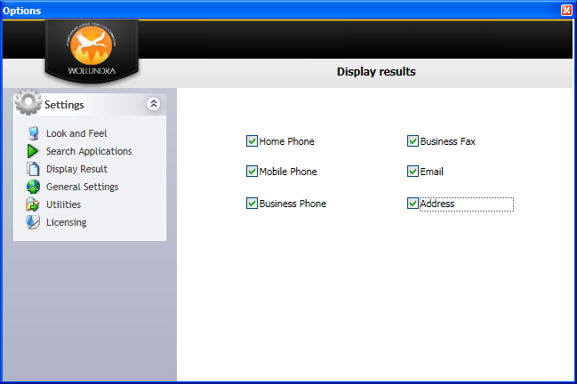

**System administrators must ensure that these settings do not contravene company policy and that private information is only available in accordance with those policies.**

Home Phone

* Select this option to display home or private phone numbers.

Mobile Phone

* Select this option to display mobile phone numbers.

Business Phone

* Select this option to display business phone numbers.

Business Fax

* Select this option to display business fax numbers.

Email

* Select this option to display email addresses.

Address

* Select this option to display the address information.

## General Settings

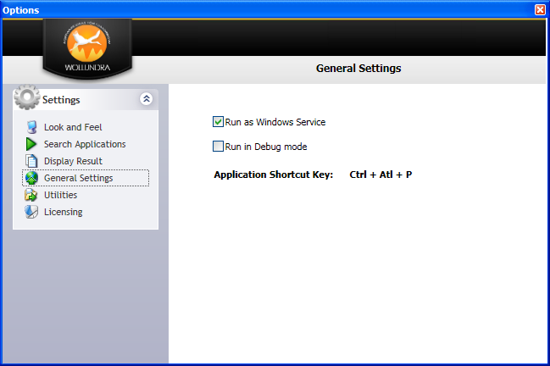

Run as Windows Service

* This check box configures the application to run as a Windows service;
* Clear this check box to run the application as a standard Windows application. This will impact on performance.

Run in Debug mode

* This option should only be used when directed to do so by the G’Day support team.

Application Shortcut Key:

* Ctrl + Alt + P is the hot key to open G’Day.

## Utilities

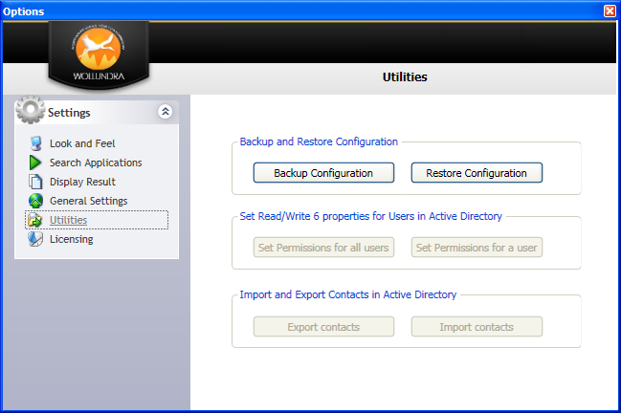

N.B. These utilities will:

Write data to your hard disk drive;

Change Active Directory permissions;

Export account details to a *.CSV file; and

Import account details into Active Directory.

These utilities are for the intend use of System Administrators and / or staff engage by Wollundra Pty Ltd to complete corporate installations. Domain Administrator privileges are required to run these utilities.

Wollundra Pty Ltd specifically absolves itself from any liability resulting from the misuse of these utilities by persons not authorised to do so by virtue of their employment or by Wollundra Pty Ltd.

**Backup and Restore Configuration**

*Backup Configuration Button*

* + This button will back up the configuration of your installation of G’Day.

*Restore Configuration Button*

* + This button will restore your saved configuration when necessary.

**Set Read/Write 6 properties for Users in Active Directory**

Active Directory gives users “READ” access only, to the 5 editable fields used by this software. Corporations that wish users to maintain these details for themselves need to change the default permissions to allow the “WRITE” permission to these 5 fields. These commands will set permissions for all user account in Active Directory or for a single account.

*Set Permissions for all users Button*

* + Set the write permissions for all accounts.

*Set Permissions for a user Button*

* + Set the write permissions for a single account.

**Import and Export Contacts in Active Directory**

Export Contacts *Button*

* + Exports the five editable fields for all users and contacts in Active Directory to a *.CSV file;
  + This file is used to verify the completeness and accuracy of the data stored in Active Directory and to add or amend data when required;
  + Administrative privileges are required to read this data from Active Directory;
  + No changes are made to Active Directory during this process.

Import Contacts *Button*

* + Imports the amended *.CSV file into Active Directory;
  + Modifies account properties, attributes, with the data specified in the amended *.CSV file.

## Product Licensing

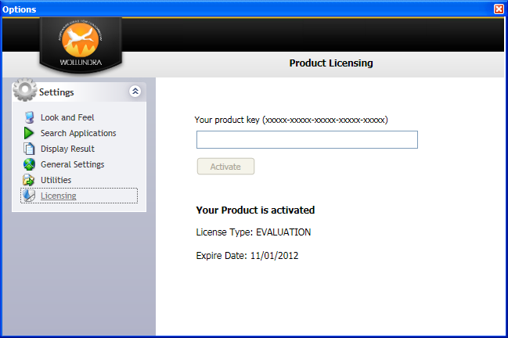

Your product key (xxxxx-xxxxx-xxxxx-xxxxx-xxxxx)

* Upon receipt of your payment Wollundra Pty Ltd will generate a license key and email that key to the email address specified;
* Copy the license key and paste it into the text field.

Activate *Button*

* Click the “Activate” button to license your software;
* The software will be activated in accordance with the license you have purchased.

Your Product is activated.

* This is informational field that identifies the type of license and the expiry date;
* Wollundra Pty Ltd will consider claims against incorrect licensing for 30 days only. Please ensure that your purchase is correctly licensed.

# How to Use G’Day

The installation process adds:

* A shortcut to the user’s desktop;
* Application shortcuts to “All Programs” “Phone Directory”;
* Starts G’Day as a service; and
* Displays the service icon in the Task Bar.

To access the G’Day service:

* Click the Task Bar icon; or
* Use the Hot Key “**Ctrl + Alt + P**”.

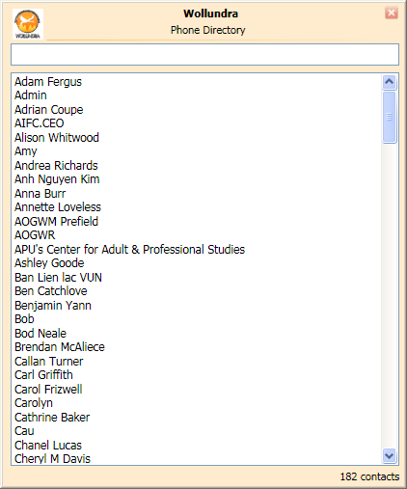

To find a telephone number:

* Type in the search bar the first character of the contact;
* To refine the search type additional characters.

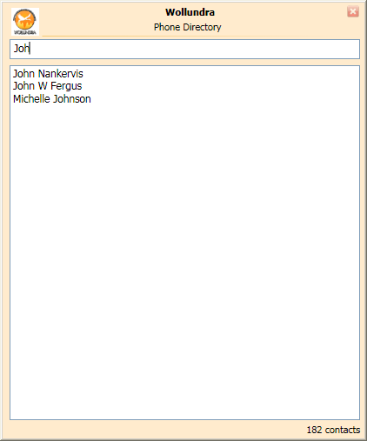

Click on the contact you are looking for to display their details;

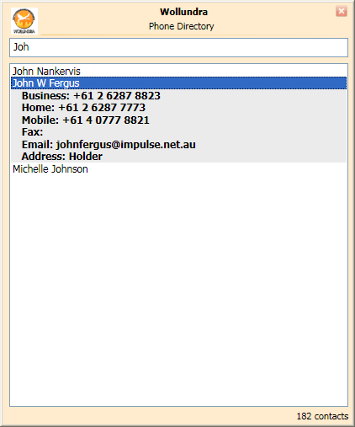

Right click on the Task Bar icon to display the user options;



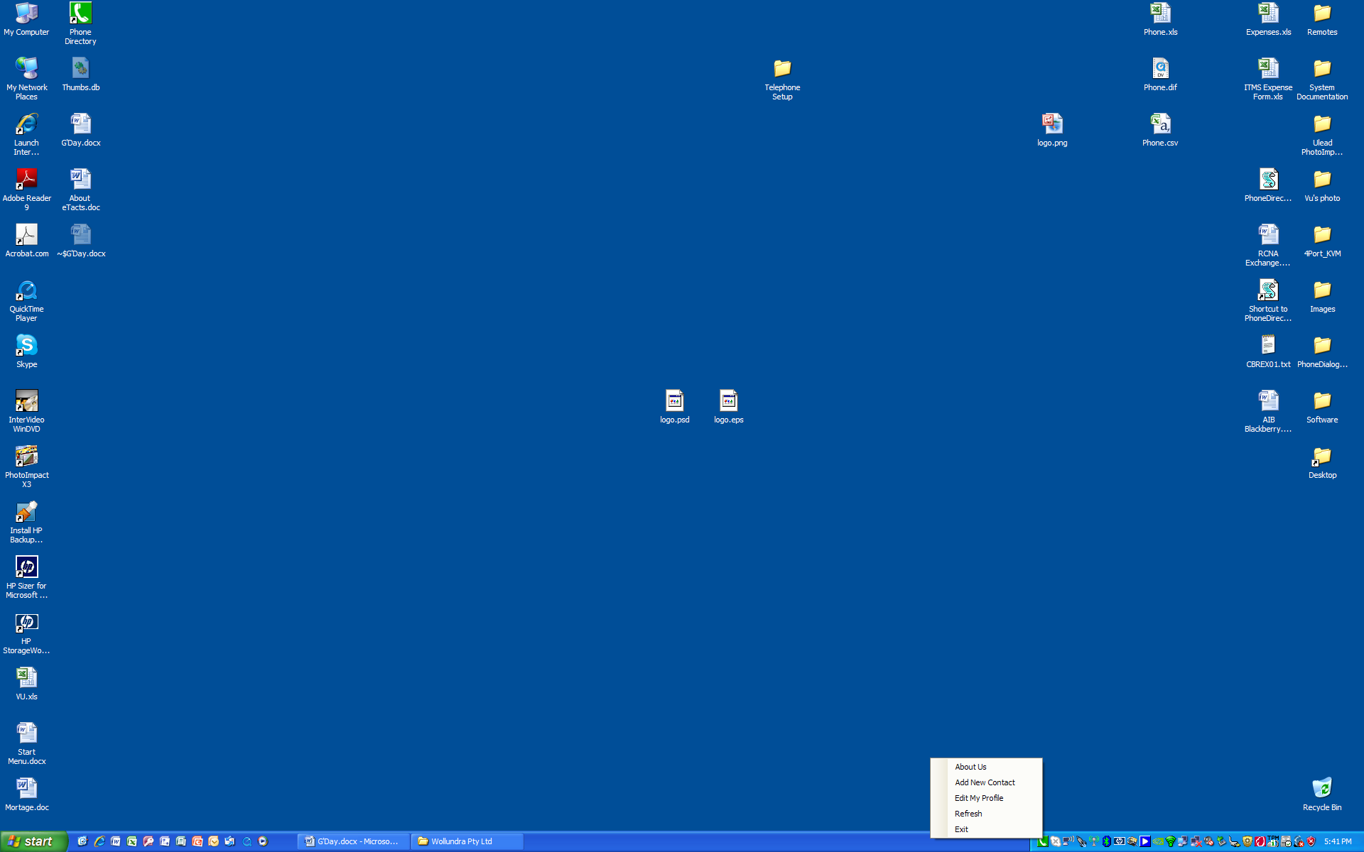

About Us:

* Users may contact [support@wollundra.com.au](mailto:support@wollundra.com.au) for product support;
* Wollundra encourages users to recommend additional features and enhancements that they believe make G’Day more effective tool.

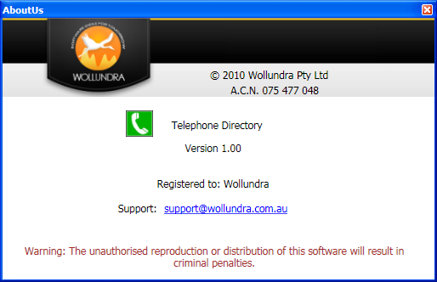

# Add New Contact

* Only works with Microsoft Outlook;
* Allows users to add a contact by completing the details and clicking “Add”

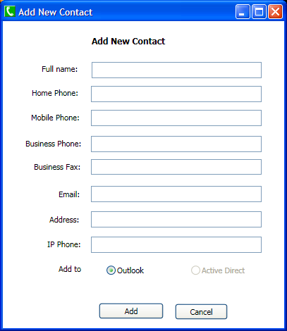

# Edit my profile:

* For companies that have a policy to allow user to maintain their own details;
* Amend the fields necessary accept email; and
* Save.

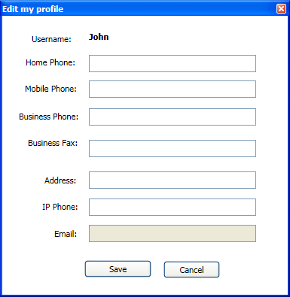

If the users does not have a connection the their Active Directory database the following error will be displayed.

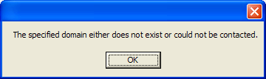

Refresh:

* Refresh will update the cached details;

# Glossary

Ctrl + Alt + P HOLD the “Ctrl” key and the “Alt” key and the “P” key